ORANGE COUNTY BACKGAMMON 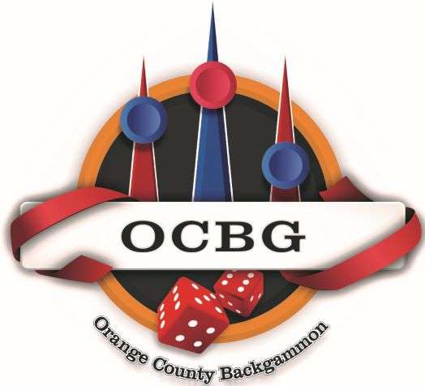 Date___________
ETIQUETTE AND RULES / Player info
Name:

E-mail________________________________________________________ Phone #_________________________________
Welcome and thank you for taking part in our backgammon competitions.
It is the goal of OUR CLUB, that everyone taking part, find it an enjoyable entertaining experience and at the same time compete, learn and enjoy the game of backgammon.
We welcome and encourage social interaction in our club,
When a match is in progress, we will abide by common sense guidelines and rules in order to maintain a friendly, amicable and respectful environment amongst players – competitors of all skill levels in our club.
Pleasantries, Small Talk or conversation during a game is fine as long as it is MUTUAL, and does not refer to the game in progress, nor causes excessive delay in match and tourney.
Below are non-negotiable guidelines to adhere by all players participating, whether playing a match or not.
A player / member that violates any of the rules below, will be issued a Caution. A second instance will result in a Temporary Suspension from all club events.
Read/ initials
___ ___ 1) During a game, PLAYERS WILL NOT COMMENT, OFFER ADVICE, or QUESTION OTHER PLAYERS MOVES, DECISIONS, STRATEGY, nor THEIR OWN. IF not playing, you may NOT comment, make remarks on other matches in progress.
___ ___ 2) THERE IS ABSOLUTELY NO WAGERING/ BETTING on a match or game at any time. It is the Venue policy and OCBG adheres by it.
___ ___ 3) OUTSIDE FOOD or DRINKS are NOT PERMITTED, Except for Water.
Others etiquette and respectful actions to follow.
- Please be courteous and silence your cell phones.
- During a match, 5 min break ok, if needed.
- POLITICS & OPINIONS on such matters can result in unpleasant conflicts these days. Please refrain.

Thank you for your cooperation and participation.

